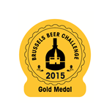

Order Form Adhesive Labels
To send back to: Becomev
Rue de Mérode 60 * B-1060 Bruxelles* Belgium
Tel: +32 (0) 2 533 27 67 - Fax: +32 (0) 2 533 27 61
Email: bbc@vinopres.com

In order to make the most of the received award, we suggest you place the official label of the Brussels Beer Challenge 2015 on your bottles.

Our tariff for this year is: (per roll of 1000)  From 1 000 to 5 000 30€/1000 +15€ for Transport
 From 6 000 to 10 000 27€/1000 +15€ for Transport
Date of delivery
expected: ________________
 From 11 000 to 30 000 24€/1000 +15€ for Transport
 From 31 000 to 50 000 22€/1000 +15€ for Transport
 > 51 000 18€/1000 +15€ for Transport

Don’t hesitate to contact us if you want to place a more important order or if you need information about other roll-systems. If this is best for you, we can make bigger rolls than 1 000.

Brewery: …………………………………………………………………………………………………………………………………………

Name of the awarded beer: ………………………………………………………………………………………………………………

Invoice address: ………………………………………………………………………………………………………………………………

………………………………………………………………………………………………………………………………………………………

Phone: ………………………………………………………………VAT: ………………………………………………………………………

E-mail: ……………………………………………………………………………………………………………………………………………

Postal address……………………………………………………………………………………………………………………………………

…………………………………………………………………………………………………………………………………………………………

I, the undersigned: ………………………………………………………………………………………………………………………………

❑ Want ………………… examples of adhesive labels reproducing the following medal.

❑ The Gold Medal  The Silver Medal  The Bronze Medal
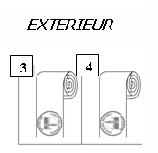
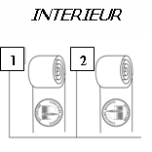

Type of label roll:
Ø Chuck 76 mm 

Ø Chuck 40 mm 

Applied by hand so type of label roll not important to me 

METHOD OF PAYMENT
Cheque are not accepted

❑ I enclose the sum of ………………€ BNP – Paribas Fortis 001-6598174-19

IBAN : BE39 0016 5981 7419 – BIC : GEBABEBB
❑ I authorise you to debit from my

❑ AMERICAN EXPRESS  VISA  MASTER CARD  EUROCARD the sum of …………€

Name of card holder: ……………………………………………………………………………………………………………

Credit card number ………………………………………………………………………………………………………………

Expiry date: ……………………………… Signature: ……………………………………………

