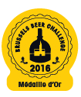
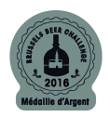
Order Form for Adhesive Labels
Return to: Becomev
Rue de Mérode 60 * B-1060 Bruxelles* Belgium
Tel: 32 0 2 533 27 67 - Fax: 32 0 2 533 27 61
Email: bbc@becomev.com

In order to make the most of your award, we suggest you place the official Brussels Beer Challenge label on your bottles, or apply the logo to your labels.

This year’s rates for ordering stickers are: (per roll of 1,000)

- From 1,000 to 5,000 €30/1000

Expected delivery date: ____________________________
- From 6,000 to 10,000 €26/1000
- From 11,000 to 30,000 €23/1000
- From 31,000 to 50,000 €22/1000
- > 51,000 €18/1000

In addition to your order price: €15 for transport and packaging for countries in Europe

€50 for transport and packaging for countries Outside Europe

Please contact us if you would like to place a larger order or if you need information about other roll systems.

Our rates for reproducing medals on labels of awarded beers:

• Less than 1,000: Free • Between 150,000 and 200,000: €9 /1 000 replicas
• Less than 20,000: €12/1 000 replicas • If more than 200,000: €1,800
• Between 20,000 and 150,000: €10 /1000 replicas

Brewery:
Invoice Address:

VAT: Tel:

E-mail: (Mandatory)

Postal address (if different to the one on the invoice):

I agree to all terms and conditions, in particular to the conditions and restrictions on reproduction copyright

Contact Person: Signature:

Cheques are not accepted

METHOD OF PAYMENT

❑ I enclose the sum of €………………
BNP - Paribas Fortis
❑ I authorise you to debit from my: rue Montagne du Parc, 3 ● 1000 Bruxelles
IBAN: BE39 0016 5981 7419 – BIC: GEBABEBB

❑ AMERICAN EXPRESS  VISA  MASTER CARD  EUROCARD the sum of €………………

+ €15 or €50 for transport and packaging costs for the stickers to countries in Europe or Outside Europe

Name of card holder:

Credit card number:

Expiration date: Signature:

Name of the awarded beer:

Beer awarded at the contest:  2012  2013  2014  2015  2016

❑ The Gold Medal  The Silver Medal  The Bronze Medal

Wishes to receive:

0 ………………… reproductions of the official medal logo. (The logo will be sent by mail)

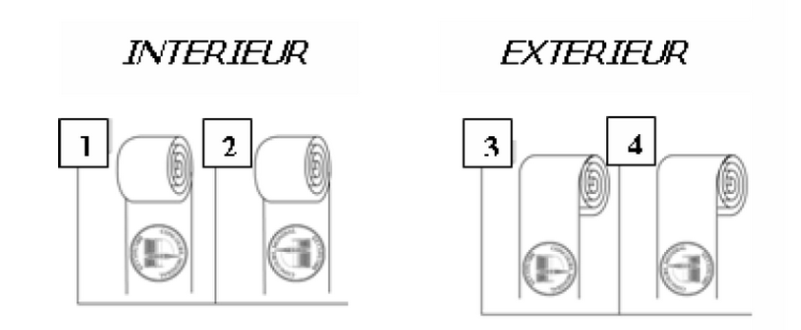
0 …………………… adhesive labels reproducing the medal.

Type of label roll:
Please choose:
Ø Chuck 76 mm 

Ø Chuck 40 mm 

Applied by hand so label roll type is irrelevant. 

Please send me rolls of:  1,000  2,000  3,000  5,000 Other: ____________

Name of the awarded beer:

Beer awarded at the contest:  2012  2013  2014  2015  2016

❑ The Gold Medal  The Silver Medal  The Bronze Medal

Wishes to receive:

0 ………………… reproductions of the official medal logo. (The logo will be sent by mail)

0 …………………… adhesive labels reproducing the medal.

Type of label roll:
Please choose:
Ø Chuck 76 mm 

Ø Chuck 40 mm 

Applied by hand so label roll type is irrelevant. 

Please send me rolls of:  1,000  2,000  3,000  5,000 Other: ____________

Name of the awarded beer:

Beer awarded at the contest:  2012  2013  2014  2015  2016

❑ The Gold Medal  The Silver Medal  The Bronze Medal

Wishes to receive:

0 ………………… reproductions of the official medal logo. (The logo will be sent by mail)

0 …………………… adhesive labels reproducing the medal.

Type of label roll:
Please choose:
Ø Chuck 76 mm 

Ø Chuck 40 mm 

Applied by hand so label roll type is irrelevant. 

Please send me rolls of:  1,000  2,000  3,000  5,000 Other: ____________

Conditions of use for reproducing medal logos from the
Brussels Beer Challenge

Any reproduction of the Brussels Beer Challenge logo, the medals and/or official stickers on the bottles or any other support is forbidden.

In order to make the most of medals won at the competition, the Brussels Beer Challenge recommends that you purchase a copyright to use the logo on the medal obtained.

This copyright allows you to reproduce the official logo of the medal you have won in order to affix labels on the bottles of beer awarded.

The conditions of this copyright are as follows:

Reproduction of the medal on labels of awarded beers:

Copyright :

Reproduction rights for the medal logo are granted by special permission only, and are individual and inalienable. They are strictly limited to the number of requested, and paid for, reproductions.

The number of replicas may in no way be higher than the number of bottles declared on the entry form for the awarded beer, at the Brussels Beer Challenge.

The reproduction copyright is limited to one year following reception of the letter of confirmation from the Brussels Beer Challenge authorizing reproduction of the logo.

The official medal logo can be reproduced only if the original proportions, diameter, font and colours are respected. No modification of any kind can be made to the logo.

Any infringement of the above will be sanctioned.

The official letter of confirmation of the copyright will be sent to you upon receipt of this form duly filled in and signed.

Supply of logo:

The logo can be sent to you upon request via email.

PS : Minimum logo size: 1.2 cm in diameter

Maximum logo size: 5 cm in diameter

